Fireworks
Did you know?
About blackpowder

The first blackpowder, now known as gunpowder, was most likely made in China in about the 10th century. The Chinese made 'firecrackers' by wrapping gunpowder in parchment and made rockets for launching from a catapault. The first person in Europe to make gunpowder was Roger Bacon, a 13th century monk. His famous recipe for blackpowder said (in old English), 'of saltpeter take five parts, five of young willow (charcoal) and five of sulfur and so you will make thunder and lightning'. The Church was not pleased about this because it was thought only God could produce thunder and lightning, so imprisoned him for ten years. Guns were invented just after Bacon's death in 1292, so he never used the term gunpowder. Today, firework makers still call the mixture blackpowder.
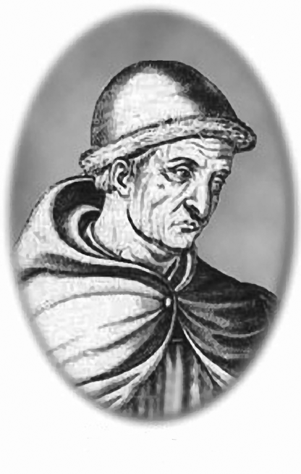

Roger Bacon
Reproduced with kind permission from Michael W Davidson.



